Nama : M. Faris Daffarindra

NIM : F1E324003

Prodi : Informatika

**Lab 9**

1. 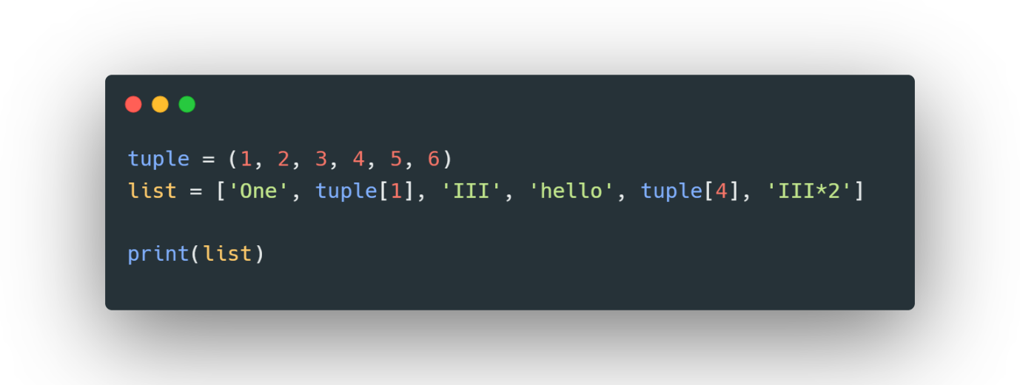
2. Kode : A screen shot of a computer

   Description automatically generated

Output :

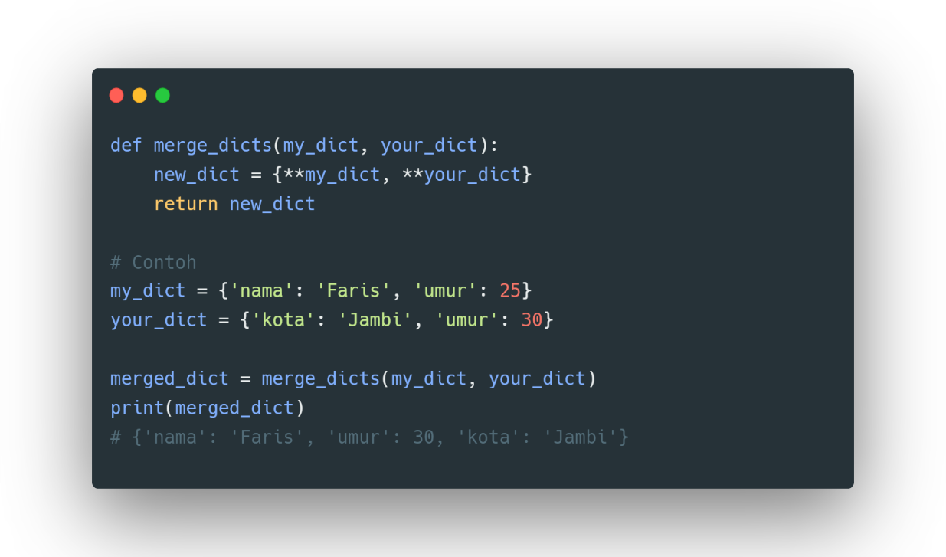

1. a.)

b.)

1. 